ECE 6810 Assignment No. 1 Zeyu Liu G24910689
The result pictures and problem solutions and MATLAB’s codes are in this word file.
The screen shots for all the code are in the Hw1a.png to Hw1e.png

This assignment requires programming, and you may use any programming languages (matlab, C, etc.) to implement them.

- Generate 1024-point white Gaussian random noise w, with zero mean and unit variance.

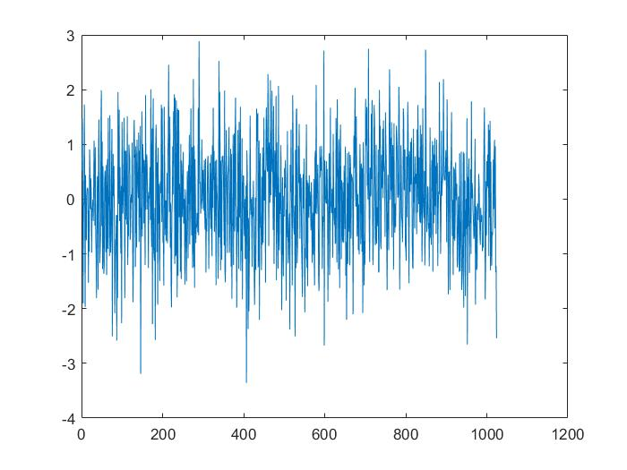

- Generate the 1024-point signal x defined by the following equation

x = zeros(1024,1);

for n= 1:1024,
x(n) = cos(0.1*pi*n) + 0.2*sin(0.2*pi*n) + 0.2*w(n);
end;

- Plot x(n).

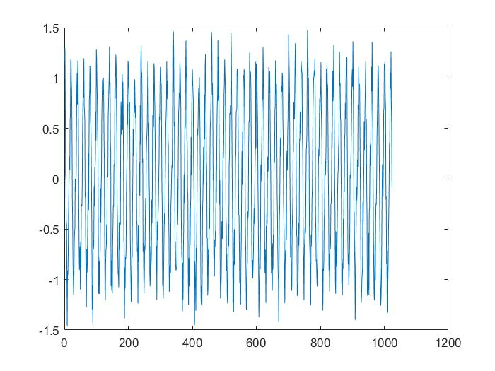

- Compute the DFT of x(n), and obtain X(k).
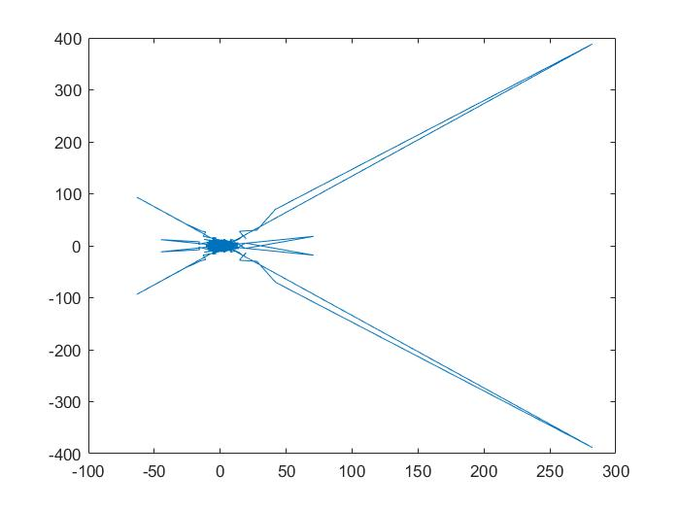

% plot real plot

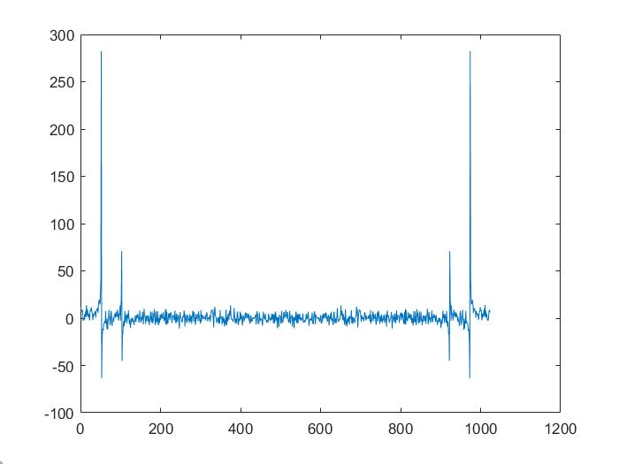

% plot imaginary part

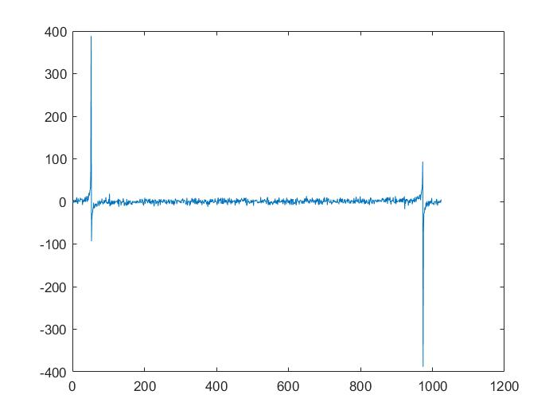

% plot magnitude

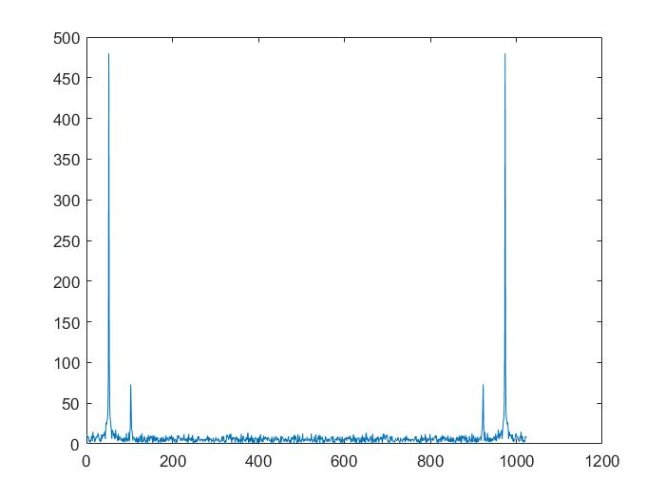

% plot phase

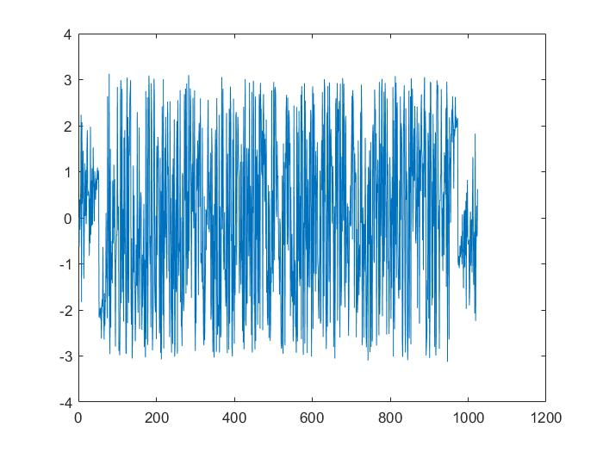

- Plot the periodogram, 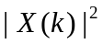 for k=1,..,512. How many peaks can you observe? What are the locations of the peaks?

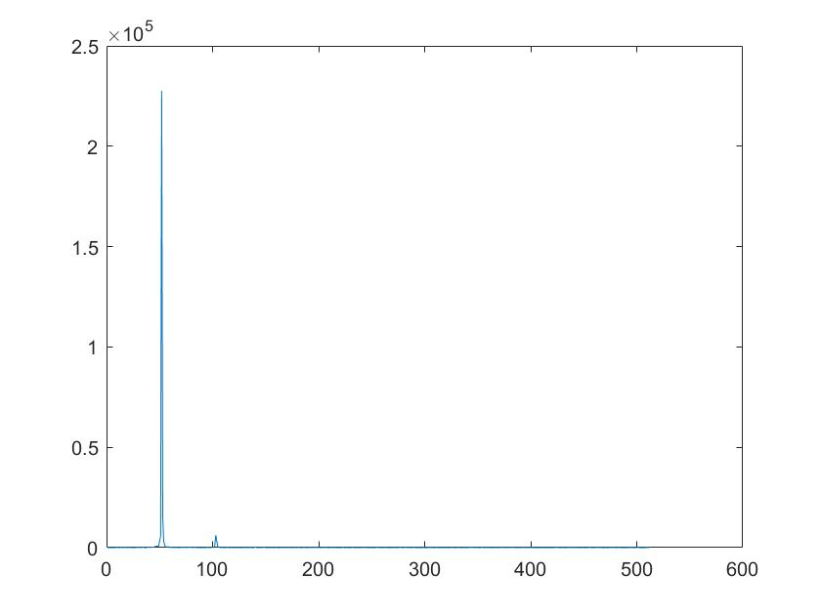

Solution:

There are two peaks can I observe. The location one is X = 52. Another one is X=103..
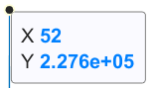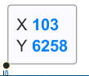
Because the whole plot when k = 1 to 1024, we only plot the half plot when k = 1 to 512,
So the peaks are 2.

- Repeat the above experiment by changing the frequency of the second sinusoid. Do you observe any differences?

% Plot x2(n).
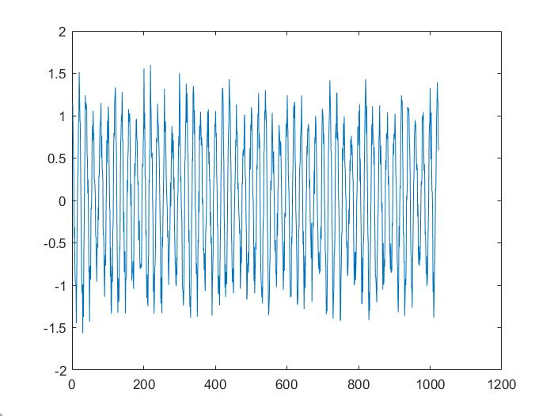
Solution:

When changing the frequency of second sinusoid from 0.2π to 0.12 π, the cos and sin frequency are more closely now. So the peak of the two sinusoid are more close then before. Although the peaks’ number are same.
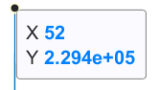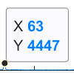
From the periodogram plot, the location of the two peaks are changed. The second sinusoid’s location become more small from 103 to 63.
So, we can infer is the frequency of the two sinusoid are same the peaks will coincide together.

% Plot X2(k)

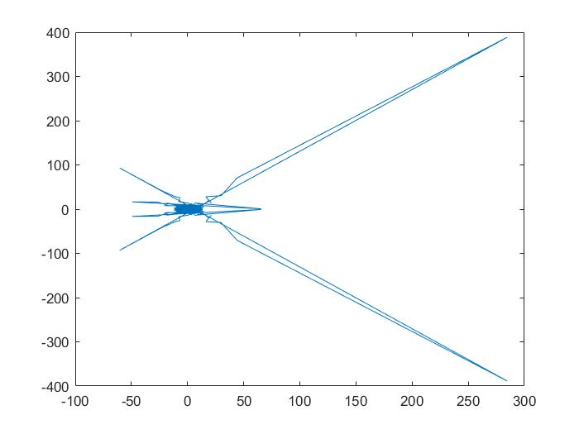

% plot real plot

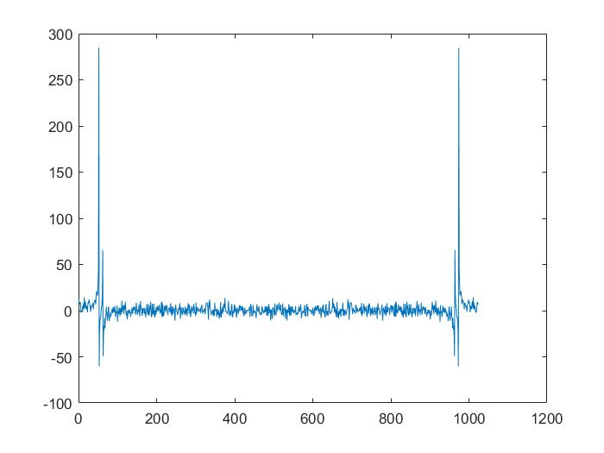

% plot imaginary part
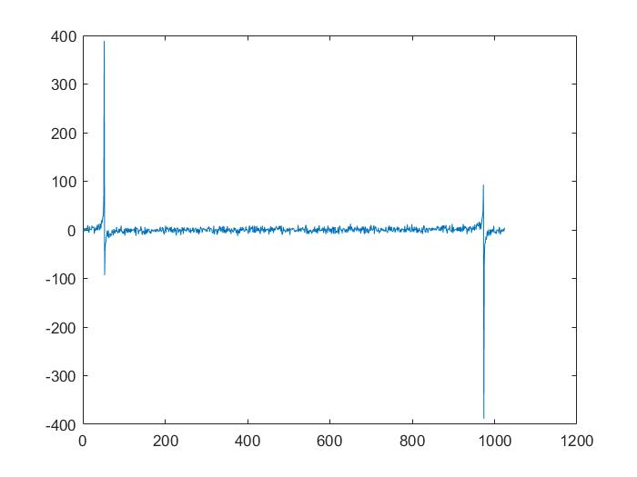

% plot magnitude

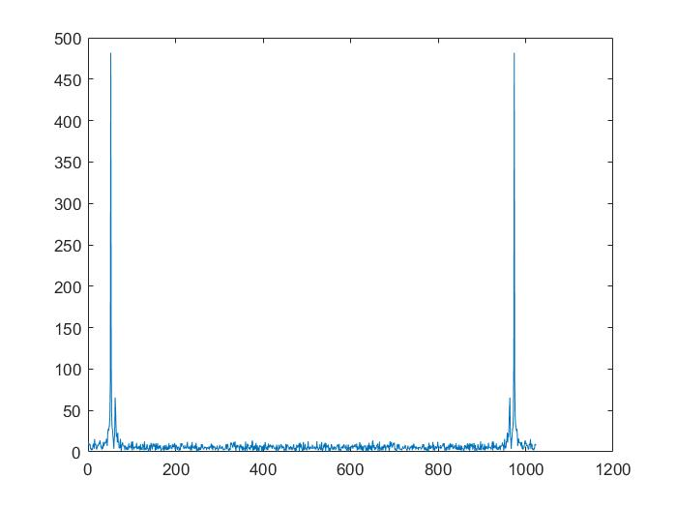

% plot phase

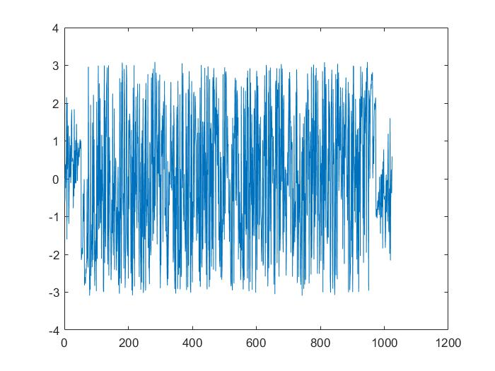

% Plot the periodogram

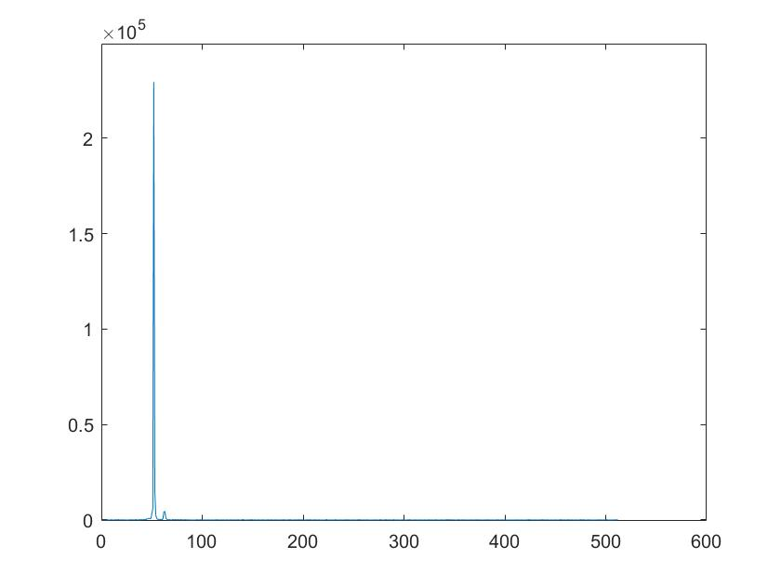

Matlab code:

% Homework 1
% Generate a signal of two sinusoids with additive white noise
% then plot, apply DFT, and computer power spectrum.
% Zeyu Liu
% Created 9/17/2019
% Revised

% function homework1
% 1. Generate 1024-point white Gaussian random noise w,
% with zero mean and unit variance.

w = randn(1024,1);
plot(w);
pause;

% 2. Generate the 1024-point signal x of two sinusoids with noise
x = zeros(1024,1);

for n= 1:1024,
x(n) = cos(0.1*pi*n) + 0.2*sin(0.2*pi*n) + 0.2*w(n);
end;

% 3. plot x(n)
plot(x);
pause;

% 4. Compute the DFT of x(n), and obtain X(k).
X = fft(x);
plot(X);
pause;
% plot real plot
plot(real(X));
pause;
% plot imaginary part
plot(imag(X));
pause;
% plot magnitude
plot(abs(X));
pause;
% plot phase
plot(angle(X));
pause;

% 5. Plot the periodogram, for k=1,..,512. How many peaks can you observe? What are the locations of the peaks?

for m = 1:512
X1(m) = (abs(X(m)))^2;
end;
plot(X1);
pause;
% plot real plot
% plot(real(X1));
% pause;
% plot imaginary part
% plot(imag(X1));
% pause;
% plot magnitude
% plot(abs(X1));
% pause;
% plot phase
% plot(angle(X1));
% pause;

% 6. Repeat the above experiment by changing the frequency of the second sinusoid. Do you observe any differences?

for n= 1:1024,
x2(n) = cos(0.1*pi*n) + 0.2*sin(0.12*pi*n) + 0.2*w(n);
end;

plot(x2);
pause;

X2 = fft(x2);
plot(X2);
pause;
% plot real plot
plot(real(X2));
pause;
% plot imaginary part
plot(imag(X2));
pause;
% plot magnitude
plot(abs(X2));
pause;
% plot phase
plot(angle(X2));
pause;

for m1 = 1:512
X3(m1) = (abs(X2(m1)))^2;
end;
plot(X3);
pause;

